Internal Assessment

Achievement Standard Digital Technologies 91073: Implement basic procedures to produce a specified digital media outcome

Resource reference: Digital Technologies 1.43 v2

Resource title: Imaging and Web Design

Credits: 4

Website Development Log

# Plan

For this Internal Assessment, I will be creating a multi-page Travel Website that integrates multiple media types. The website will be structured and styled using HTML5 and CSS3 (respectively), and will integrate numerous images and vector graphics throughout the website.

Text content will either be written by me or sourced from Wikipedia, licenced under the Creative Commons Attribution-ShareAlike 3.0 License. Images will be shot by myself ad-hoc or be sourced from my family’s archive of previously shot images.

# Productivity Techniques

I plan to divide this task into related groups of sub tasks called ‘Sprints’. Each Sprint will focus on the implementation of a specific feature or group of features and will continue until completion. This ensures that the task is completed in a logical and orderly manner, and certain components are not left uncompleted by accident.

For example, a typical Sprint may look and act as follows:

## Example Sprint

* **Pre-Implementation Plan**

Initial design decisions here…

* **HTML Structure**

Implementation details here…

* **Styling**

Implementation details here…

* **Review**

Changes to initial plan and details of implementation…

## Specifications

The specifications for this project are:

* Create a multi-page website.
* Create navigation to efficiently travel between pages.
* Create a user-friendly design that is accessible and visually pleasing.
* Create a UI scheme that is consistent throughout the website.
* Create a fully responsive website that can adapt to screens of any shape and size across a range of device types.
* Use a range of different images (Vector Graphics, PNGs, JPGs, etc).
* Enhance and integrate images into the website through advanced CSS techniques.
* Add visual flair through use of CSS Transitions on interactable elements.
* Have the ability to be displayed in three or more different browsers.

# Editor

I have chosen to use Microsoft’s cross-platform text editor Visual Studio Code. It comes complete with syntax highlighting, built in file management, integrated terminal, and split-view for increased productivity. Due to VSC being my text editor of choice, I have chosen it for familiarity, and for relatively higher productivity compared to other editors, which I am less familiar with.

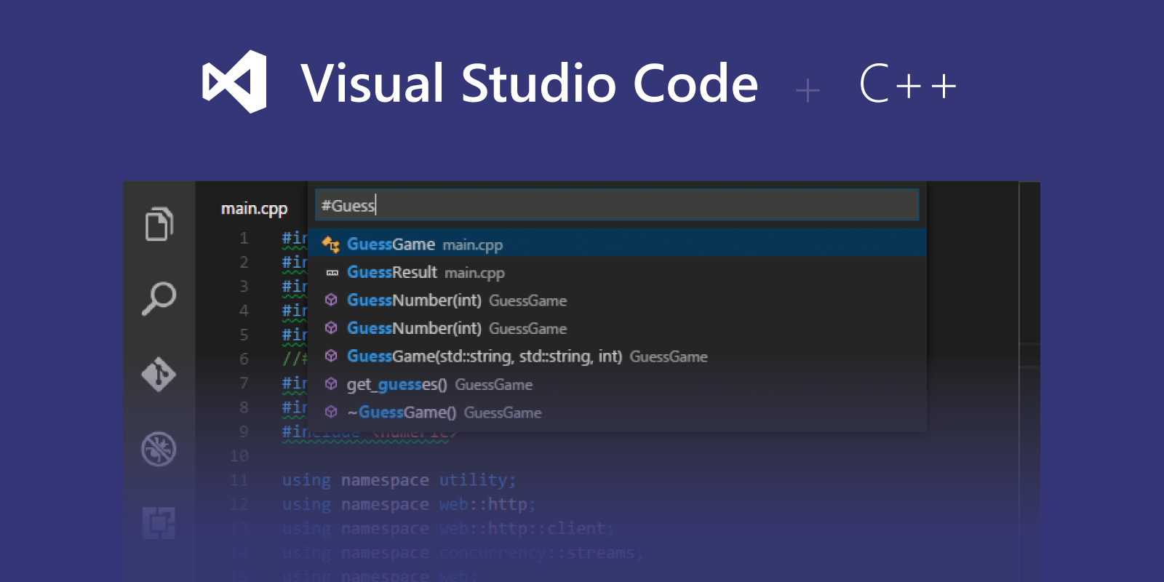

**Figure 1:** I have previously used Visual Studio Code for C++ Development, and are thus familiar with it for programming efficiently.

Journal

## Sprint 1: Landing Page

**Pre-Implementation Plan**

Friday 19th May 2017

The task requires the implementation of multiple media types. I decided on using HTML5 and CSS3 to create a Travel Website which integrates vector graphics and images shot by myself.

I began browsing the internet for reference templates and ideas for website design. I found a wide range of different layouts for travel websites, but decided to take inspiration primarily from the ‘TravelTours’ theme by GoodLayers (see <https://demo.goodlayers.com/traveltour/>). I created basic layout mock-ups in Photoshop (CS5), which can be seen below.

|  |  |
| --- | --- |
|  |  |

**Figure 2/3:** Mock-ups of possible navigation/landing page layouts. These were inspired by the ‘TravelTours’ and ‘Your Trip’ themes.

Tuesday 23rd May 2017

Today, I began creation of a large portrait-oriented overview of the website’s layout using Photoshop. I decided to use a modified version of the first design concept as the initial layout for my website. While I expect to heavily modify the initial design as I construct the website, this design will act as guidelines for the basic structure and implementation of the HTML mark-up.

Wednesday 24th May 2017

I continued creation of my own template design, adding sections for recommended tours, ‘hero’ image, placeholder footer, and refined the initial navigation slightly. I switched from a ‘matte-painting’ like appearance using random images from the internet (see figure 2 and 3 for reference) to a monochromatic colour palate and primitive shape construction.

Friday 26th May 2017

I continued refining and changing my custom template design, referring to other Travel-related themes I found on the internet. I took responsiveness into consideration while designing the template, as I plan to implement a fully responsive four or five stage breakpoint system (xsmall, small, medium, large, xlarge) in the near future.

Tuesday 30th May 2017

I finished my template design over the weekend. It revolves around a ‘stacking’ structure, in which all controls reside in sections (with the exception of the navigation bar), and each section is self-contained. This allows for ‘picking and mixing’ of sections to rapidly create new pages using existing components, drastically improving productivity.

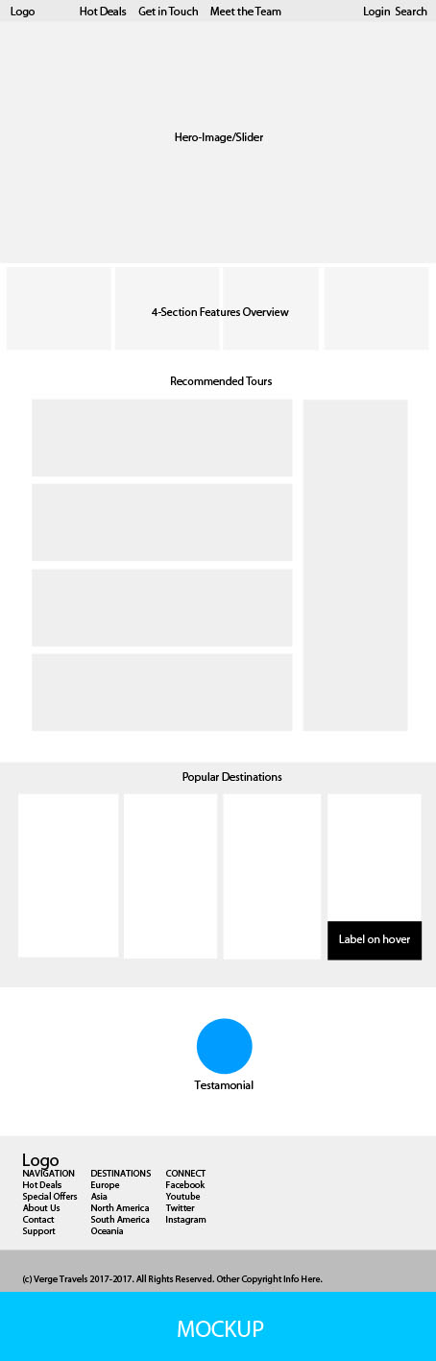

**Figure 4:** Finished concept of the Landing Page. The full mockup can be seen in the file: *‘travel_landing_concept.jpg’.*

**Structure & Styling**

Due to the ‘stacked’ nature of this page, I have decided to structure and then style each section one at a time, so that I can decide how to approach the next section with minimal code rewrites.

Wednesday 31st May 2017

I began to experiment with HTML website design, trying out various colour combinations, and navigation designs. I decided to mirror the template with a fixed, full-length horizontal navigation bar. I set the navigation bar to use a linear gradient background between black and ‘transparent’, to give a vignette-like effect to the Hero Image. The navbar uses absolute positioning to always remain above the hero image.

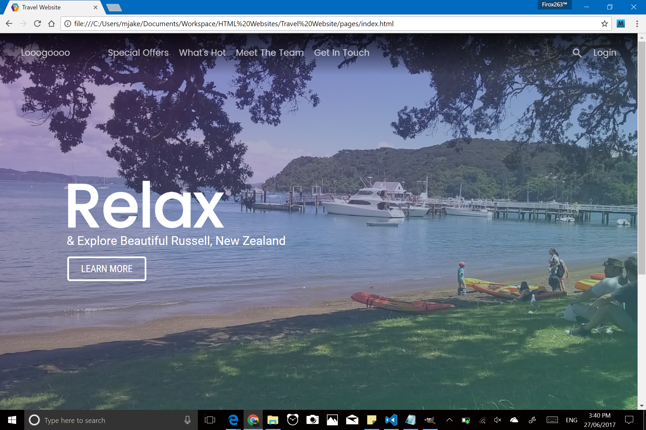

**Figure 5:** A gradient backdrop was used to simulate a vignette. (NOTE: This picture was taken after the hero-image had been added, as the effect was not clearly visible previously). ‘Logo’ is a placeholder for actual SVG Logo, which will be added later.

Friday 2nd June 2017

I began work on the ‘hero-image’. Rather than using a ‘<section>’ element, I decided to use ‘<header>’, to maintain the typical structure of an HTML5 document (the page contents is ‘wrapped’ by a header and footer). I set the height to be ‘100vh’ (100% of the viewport height), and made the element full width.

Tuesday 6th June 2017

I experimented with a range of different Hero Image styles. I set the background to be a picture of Russell (New Zealand), which I took several years ago. I determined that the plain colour photo did not blend in well with the navbar, and looked ‘tacky’ and visually unpleasant.

I experimented with adding a vignette, but decided that the gradient background of the navigation bar was sufficient to fade in the image. I settled on adding a gradient overlay, using the website UI Gradients for complementary colours (<https://uigradients.com/#CalmDarya>).

Wednesday 7th June 2017

I created a text overlay that contains promotional text related to the hero image. It consists of a large ‘statement’, a subtitle, and a hover button. I chose ‘Poppins’ as the font for the heading, which reads “Relax”. The subtitle reads “& Explore Beautiful Russell New Zealand”. The button is an anchor element (‘<a>’), with a 3px white border and a border radius of 5px.

The font for the subtitle is ‘Roboto’, while the button uses ‘Roboto Condensed’. All fonts use built in fall-backs similar to the primary font in the case that the font is unable to be displayed by the browser. The fonts are hosted locally in the “css/ext” folder, using the Web Font Format (woff2) for maximum compatibility.

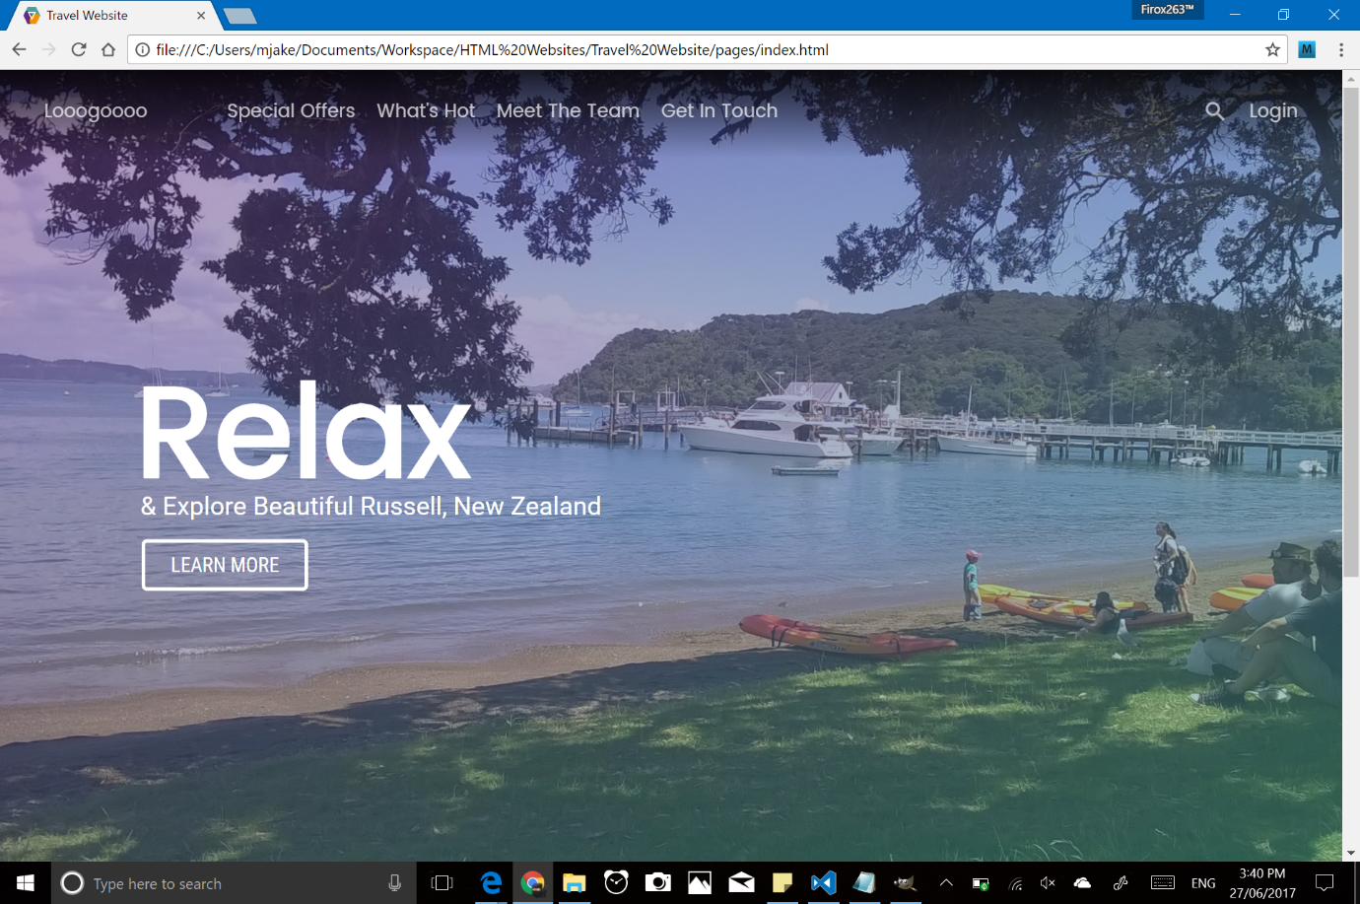

**Figure 6:** Hero Image with gradient overlay (purple to teal, top-left to bottom-right). Hero Text positioned absolutely over background, wrapped inside ‘<div> element’.

Friday 9th June 2017

I experimented with button transitions to add a bit of extra flair to the ‘Learn More’ button. Upon hovering, the button text will slide to the left, and an arrow will appear sliding in from the right. The background will turn the same teal colour used in the gradient overlay, with a slight transparency applied.

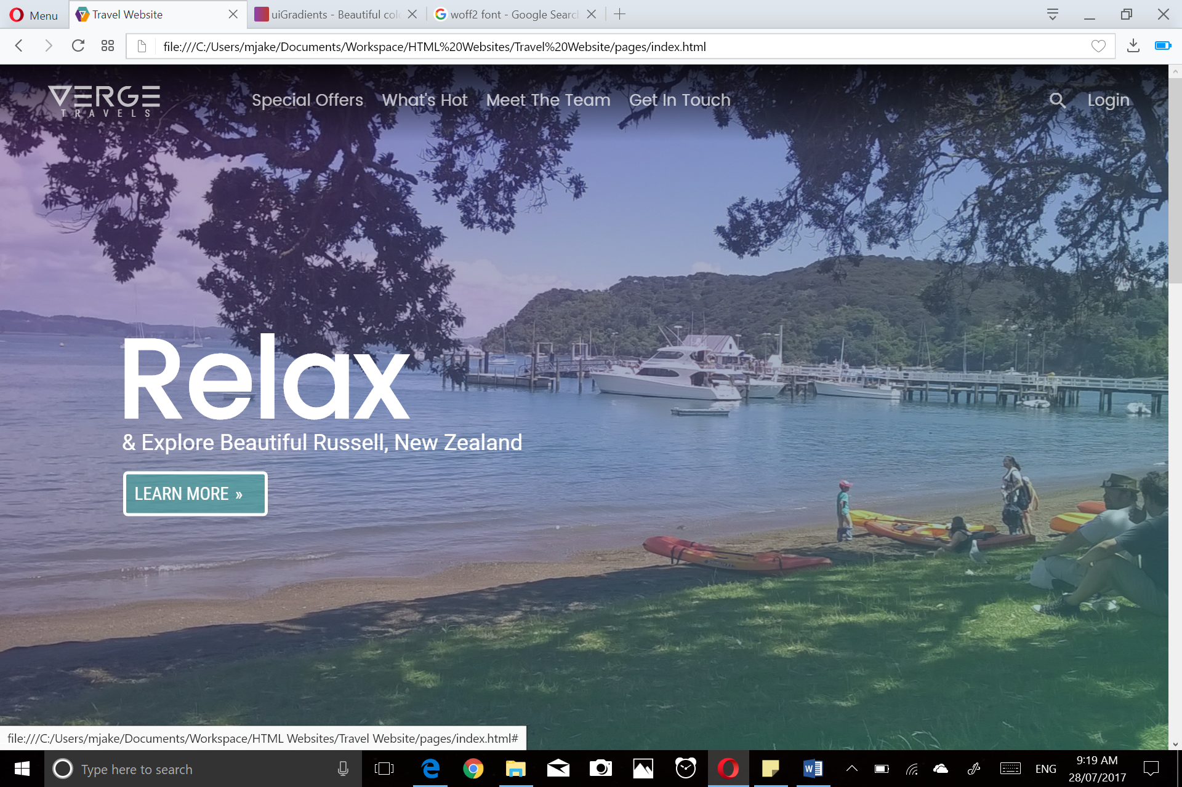

**Figure 7/8:** Effect of button hover. CSS Transitions are used to interpolate between the off (left) and on (right) states.

Tuesday 13th June 2017

I began work on the next section – a ‘features’ panel which shows the four steps needed to use the Travel Service. I decided on a combination of ‘Landing’, ‘Fetching Baggage’, ‘Collecting Passes’, and ‘Being Ready’ for the four features, based on the availability of their corresponding icons in the Material Icons icon font, which I used for all the icons in this project. I initially made all the icons black, and laid them out horizontally using floats, however this responded negatively to responsive friendly design and I reconsidered my approach.

I settled on using a flexbox to lay the four elements out horizontally, while opening up future possibilities for a responsive layout. I found the black and white too monochromatic, instead using Indigo, Red, Amber, and Green from the Material Colours Presets (<https://material.io/guidelines/style/color.html#color-color-tool>). The description text has a lowered opacity for subtlety.

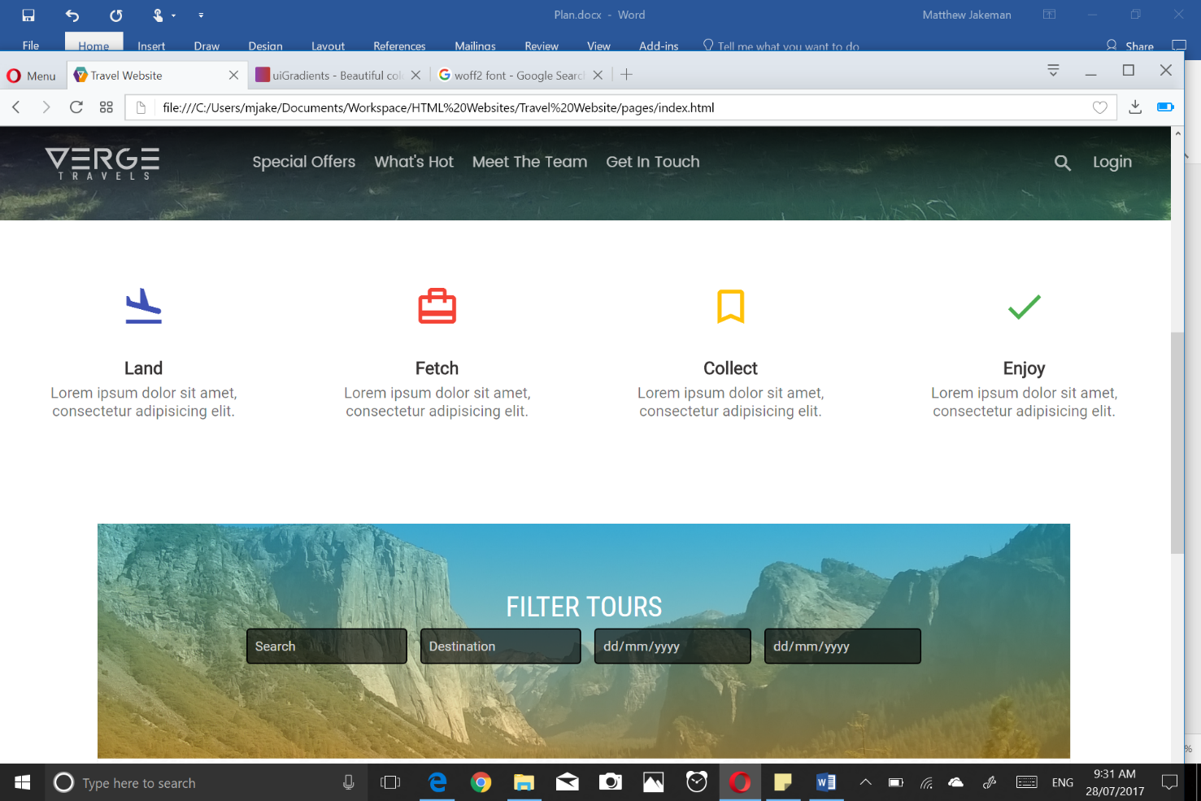

**Figure 9:** The features section. Each ‘feature’ takes up 25% off the section, and ‘Lorem Ipsum’ is used as placeholder text.

Wednesday 14th June 2017

I continued work on the features section, adding a ‘hover effect’ for increased interactivity with the page. The hover effect consists of a various levels of text shadow for the icon and heading respectively, while the text gains full opacity.

Friday 16th June 2017

Before continuing to the Recommended Tours section, I decided to update the navbar. I made the gradient slightly less pronounced, and changed to hover effect from a darker gradient to a simple increased opacity hover, using transitions to make the effect smooth. I also added right aligned buttons for Searching and Logging In. The search button uses the Material Icons ‘Search’ icon.

Tuesday 20th June 2017

When looking at the navbar over the non-image contents of the page, I did not like the gradient effect. I experimented with various techniques in order to create a JavaScript free ‘sticky navbar’. I changed the navbar to used fixed positioning and positioned it above everything else on the page using ‘z-index’.

I then made the Hero Image use absolute positioning and set it just below the navbar. I added a backdrop for the navigation bar and positioned it below the hero image, so that it is not visible when the navbar is over the image, but slides out for the rest of the page. This effect is illustrated below:

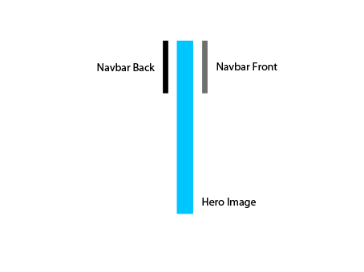

**Figure 10:** Illustrated side view of the website (from back to front 🡪).

This gives the following effect when scrolling down. I decided to use a semi-transparent black colour to preserve the gradient/vignette effect, while still looking visually appealing. The effect appears as follows:

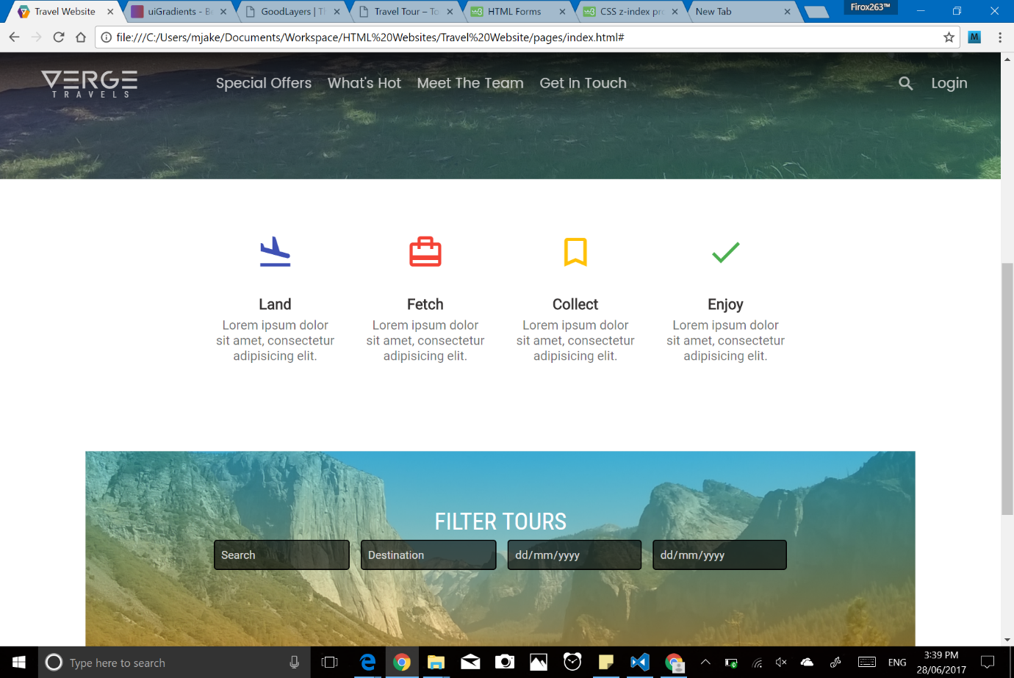

**Figure 11:** Navigation Bar over Hero Image – Gradient Backdrop. This screenshot was taken after the logo had been designed. Creation process of logo can be seen below.

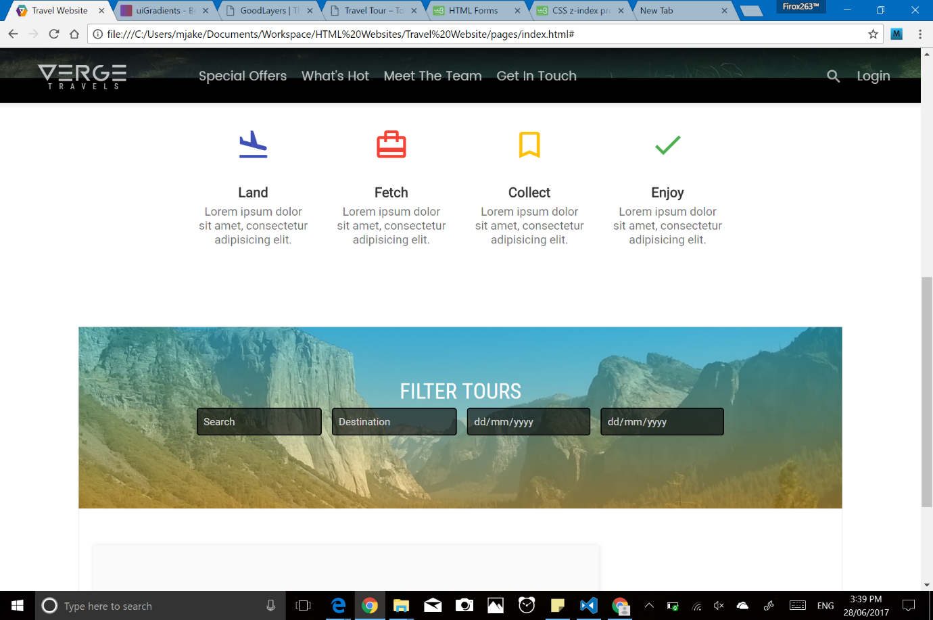

**Figure 12:** Navigation Bar half over Hero Image, half over rest of page – Solid Black Backdrop for emphasis.

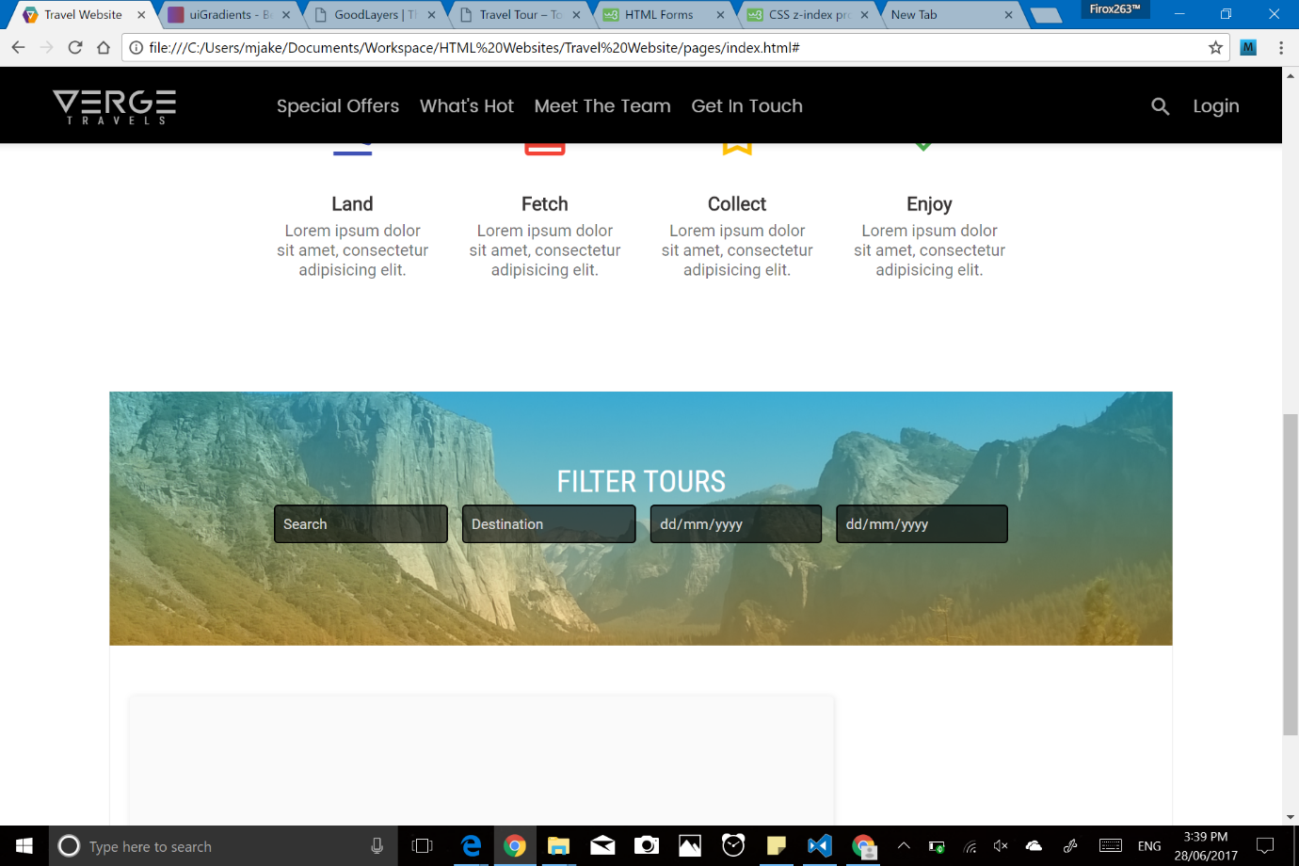

**Figure 13:** Navbar with Solid Black Backdrop over contents.

Wednesday 21st June 2017

I continued working on, and bug fixing the navigation bar. I added a ‘quick fix’ span element to resolve the offset issue caused by the Hero Image’s absolute positioning.

Friday 23rd June 2017

As part of my process of updating the navbar, I decided to name my website and create a logo for it. I decided on the name ‘Verge Travels’. Verge means ‘an edge or extreme limit’, as Verge Travels takes you to the edges of the world. I began researching ‘v’ shaped logos for my Navigation Bar logo, and decided to use a hollow upside-down triangle (symbolising the v) inside a multicoloured hexagon.

Monday 26th June 2017

I continued experimenting and refining my logo. I taught myself the essentials of illustrator so I could make a vector logo that scales properly across all devices. I added coloured circles inside the teal coloured hexagon and used illustrator’s masking tools to hide the overflow.

Wednesday 28th June 2017

I finished my hexagon logo and created a complimentary white/transparent version of it. The two logos look as follows:



**Figure 14:** Coloured version of the Verge Travels logo.

Friday 30th June 2017

I decided to make a Verge Travels logo (with the full Verge Travels text). I decided on a material design inspired geometric logo. I took the ‘V’ element from the hexagonal logo and decided to create a ‘square letter’ logo from it (in the sense that each letter fits inside a square).

Tuesday 4th June 2017

For the letter ‘E’, I used three horizontal lines, equally spaced. I began work on the ‘R’, using a combination of circles and angled lines. I used illustrator’s masking to retain the vector properties.

Wednesday 5th June 2017

I continued work on the logo. I reduced the width of each letter (except the ‘V’), as the square letter logo looked too drawn out. This involved redoing part of the letter ‘R’. I also finished the letter ‘G’. It is primarily created out of a circle. I added another ‘E’ to the end and added the subtitle ‘TRAVELS’. I saved it as an SVG and added it to the Navigation Bar. I manually edited the SVG contents in order to apply the locally hosted ‘Roboto Condensed’ font to the subtitle. The logo looks as follows:

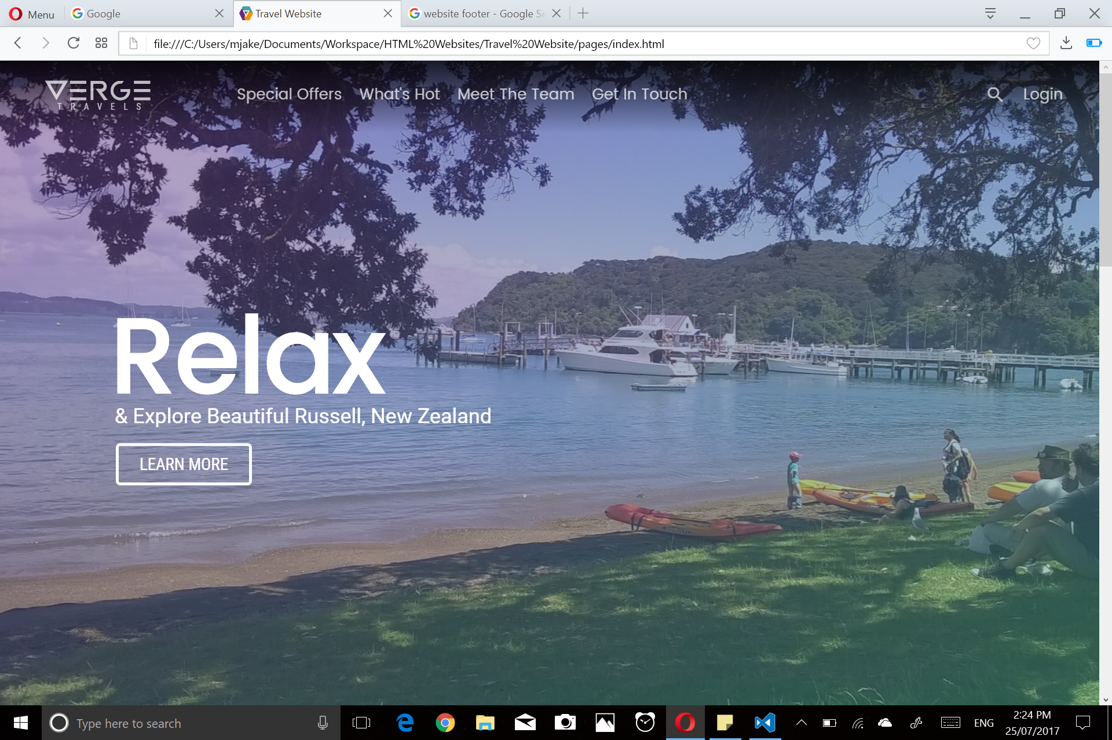

**Figure 15:** The Verge Travels logo in the Navigation Bar. It is partially transparent, and gains 100% opacity upon hover.

Friday 7th June 2017

I began work on the ‘Recommended Tours’ section of the page. All content is wrapped inside a ‘section wrapper div’, which takes 90% of the page width (plus 50px of padding). I created a heading that reads ‘FILTER TOURS’, and an HTML form with options for filtering tours by keywords and dates. HTML5 date pickers were used for the start and end dates of the trip. I set the background to be a picture of El Capitan in Yosemite, and added a gradient overlay (amber to turquoise, bottom to top), which I also sourced from UI Gradients (<https://uigradients.com/#Summer>).

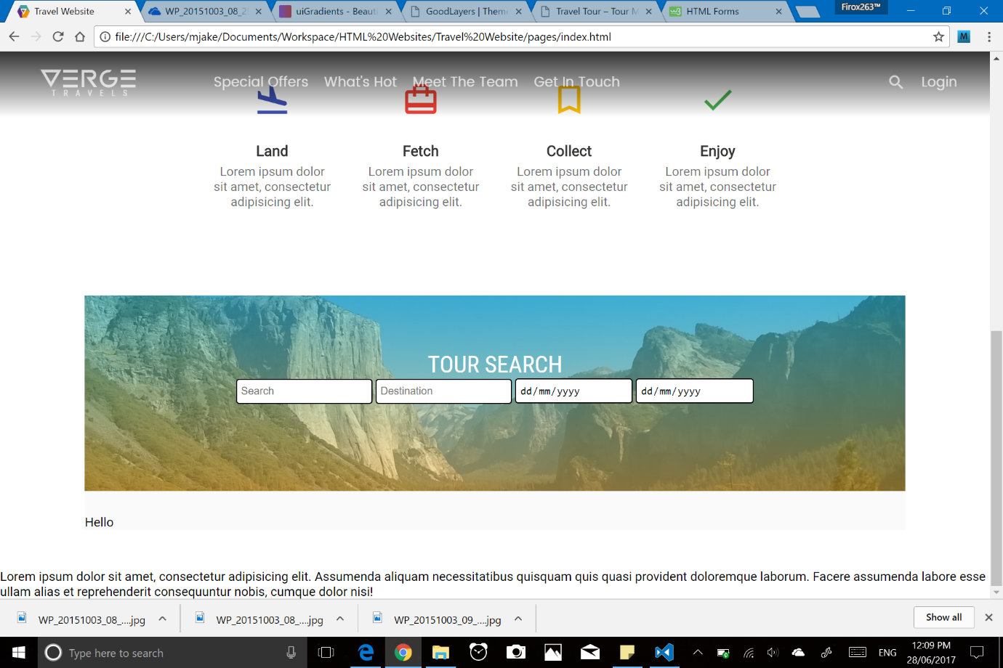

**Figure 16:** Work in progress version of the Tour Filters part of the Recommended Tours section. HTML date pickers are used for the two last inputs.

Tuesday 25th July 2017

I spent today making sure my planning document was fully caught up, and that all spelling/grammatical errors were fixed. I began to add screenshots to the document from my picture archive, which I took during the initial creation and design of the website.

I continued working on the Recommended Tours section, using dark grey styles for the inputs to better blend in with the background. I created an animated ‘submit’ button, reusing code from the ‘View All’ button in the hero text. It consists of a top and bottom white border. I also added labels to the textboxes.

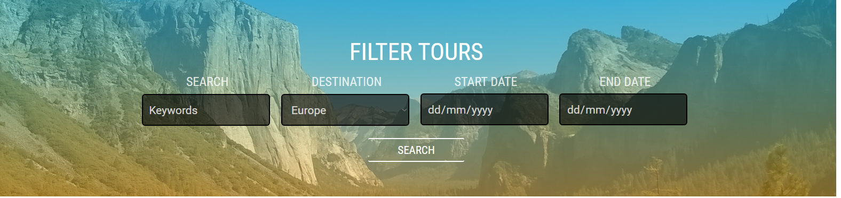

**Figure 17:** The Filter Tours ‘header’ of the Recommended Tours section. The labels have reduced opacity to blend in to the background.

I also started the tour list section. I divided the section into two main parts – the tour list and the sidebar. Material Design inspired ‘cards’ for each tour destination were added, consisting of an image, a gradient overlay with colours complimentary to that image, as well as summary details about the tour. I added a ‘ribbon’ using CSS and absolute positioning to draw attention to the cards.

For the background of the Recommended Tours section, I decided to use a tillable background image. I chose to use ‘Swirl’ from the website Subtle Patterns, as it is royalty free and licensed under the CC-BY-SA 3.0 License (attribution is provided through a sentence in the footer of the page).

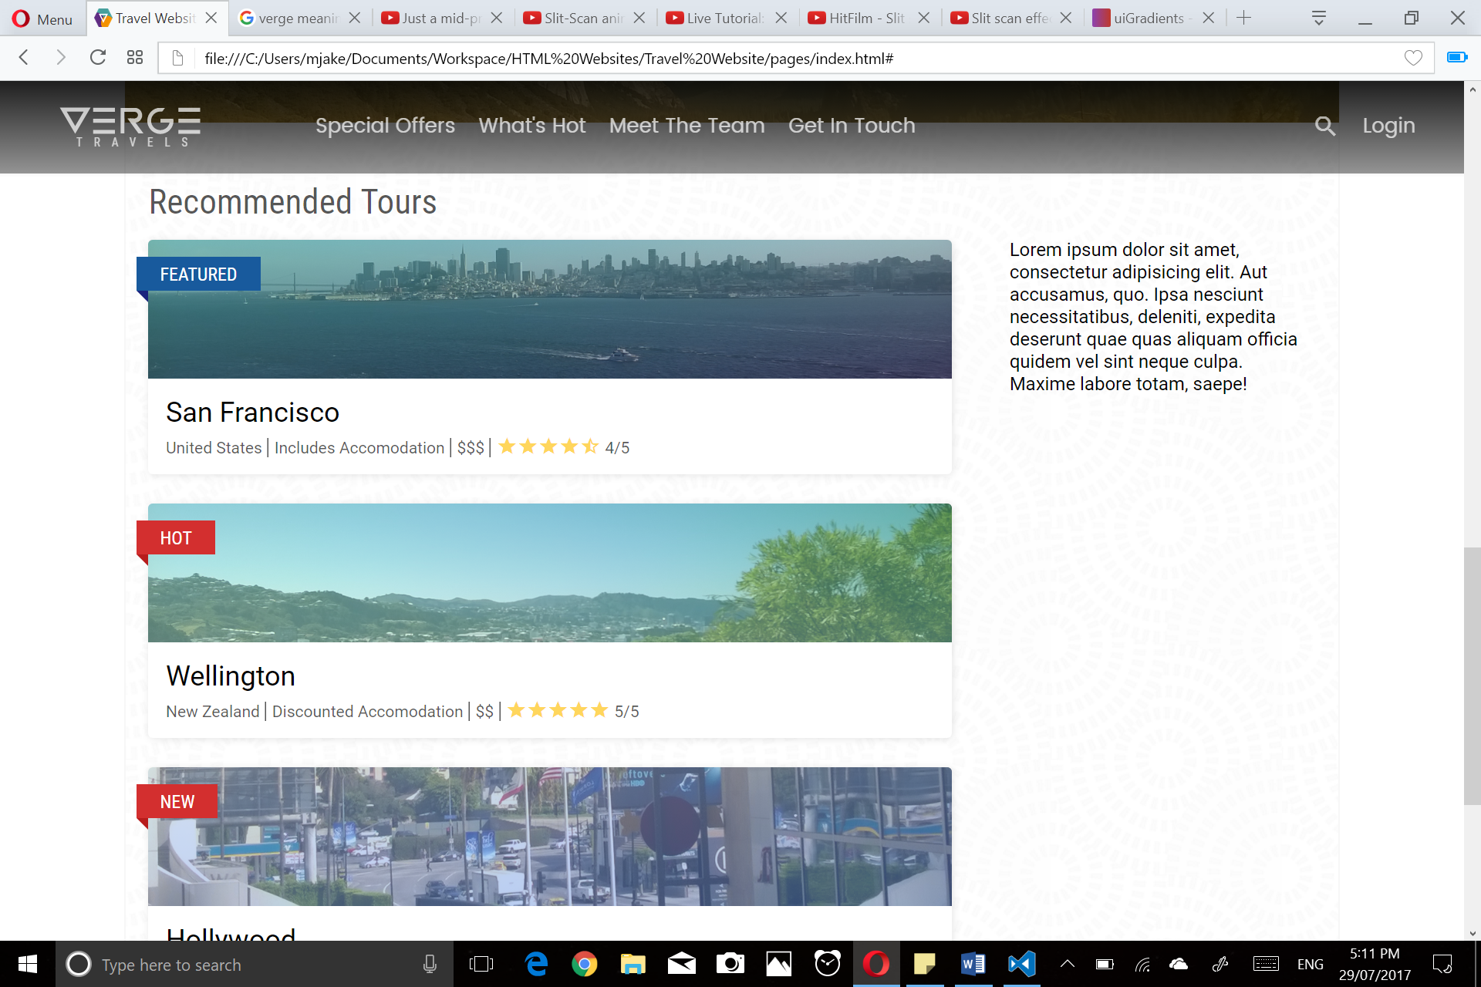

**Figure 18:** Snapshot of the Recommended Tours section, including cards for ‘San Francisco and Wellington’. Lorem Ipsum acts as placeholder text, and will be substituted in a later Sprint.

Wednesday 26th July 2017

I added a button to the bottom of the three cards to provide a means to ‘See All Tours’. The button is a slightly modified version of the ‘Learn More’ button for the Hero Image, using underlining instead of background colour for emphasis.

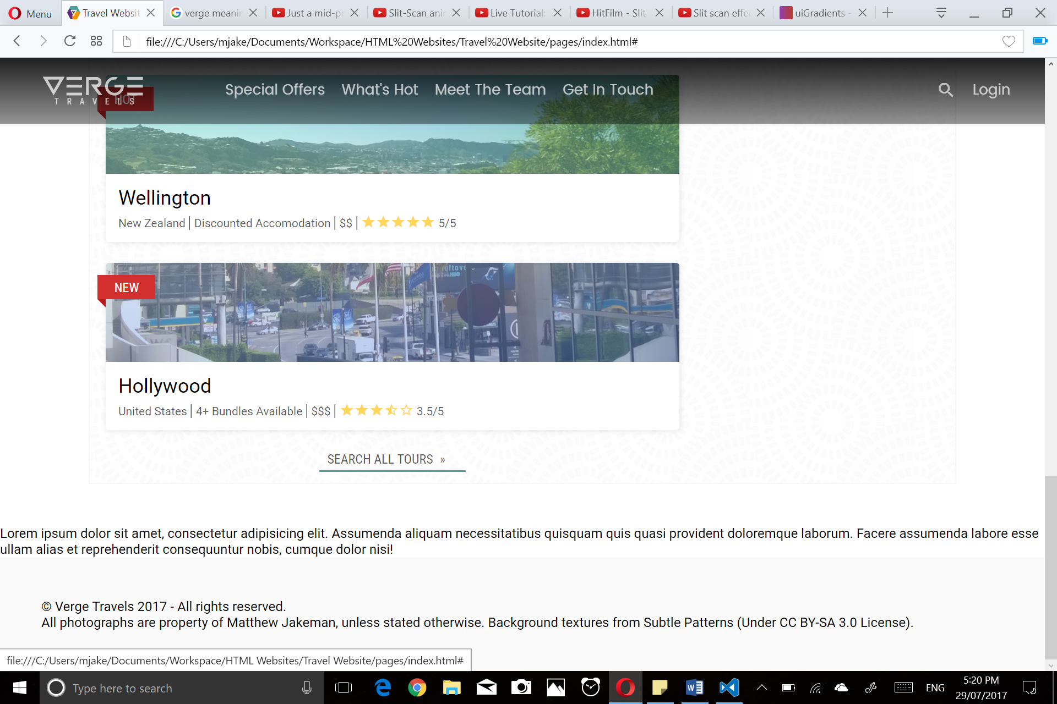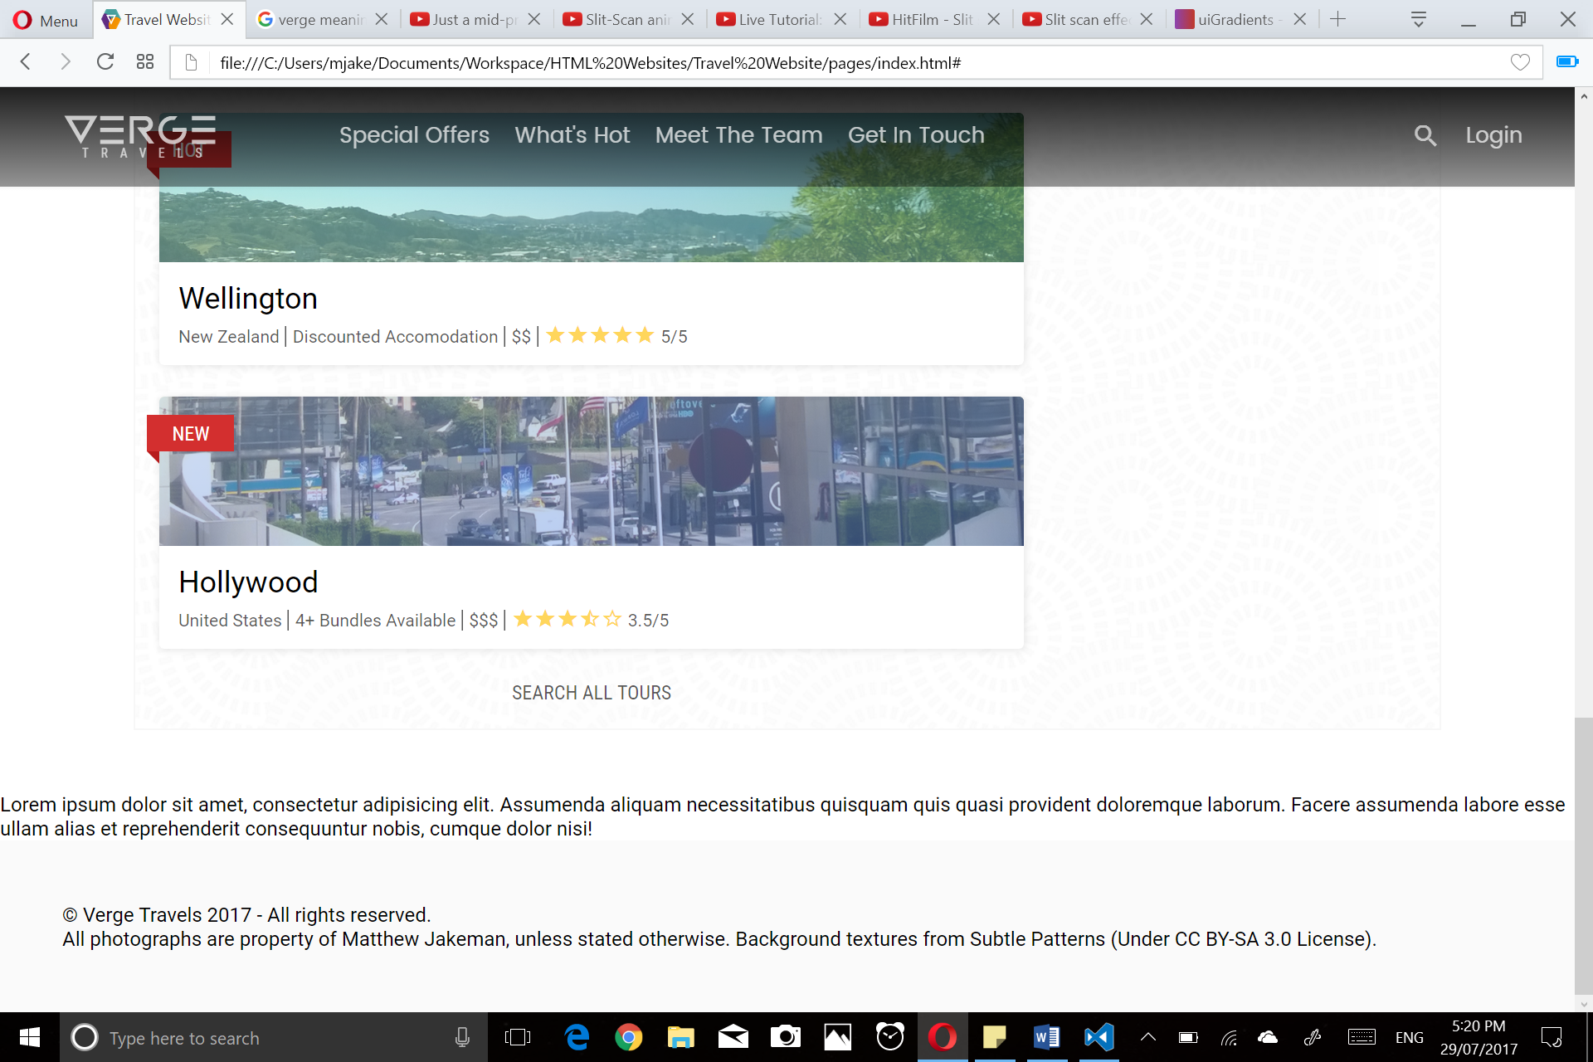

**Figure 19/20:** Search All Tours button. CSS Transitions are used to interpolate between Inactive (left) and Active (right) hover states.

Friday 28th July 2017

I started work on the ‘Destinations’ section. I decided to modify the initial concept, showing all destinations (Europe, Asia, North America, South America, and Oceania), rather than just a few select popular ones. Africa is excluded as I did not have any pictures from the African continent readily available to me. This section will consist of a section element, with five 20% width article elements inside, positioned using a flexbox. Each article will correspond to one of the five destinations listed above, and will show a thumbnail for that region.

I decided to give each destination a transparent to black gradient overlay, with an opacity of 0.2, which increases to 0.7 upon hover. This provides user feedback to show the items are interactable and makes the ‘information text’ more readable. I also added a divider SVG from Clipart Panda, at the end of the section for extra visual flair (<http://www.clipartpanda.com/clipart_images/black-swirl-divider-clip-art-5662421>).

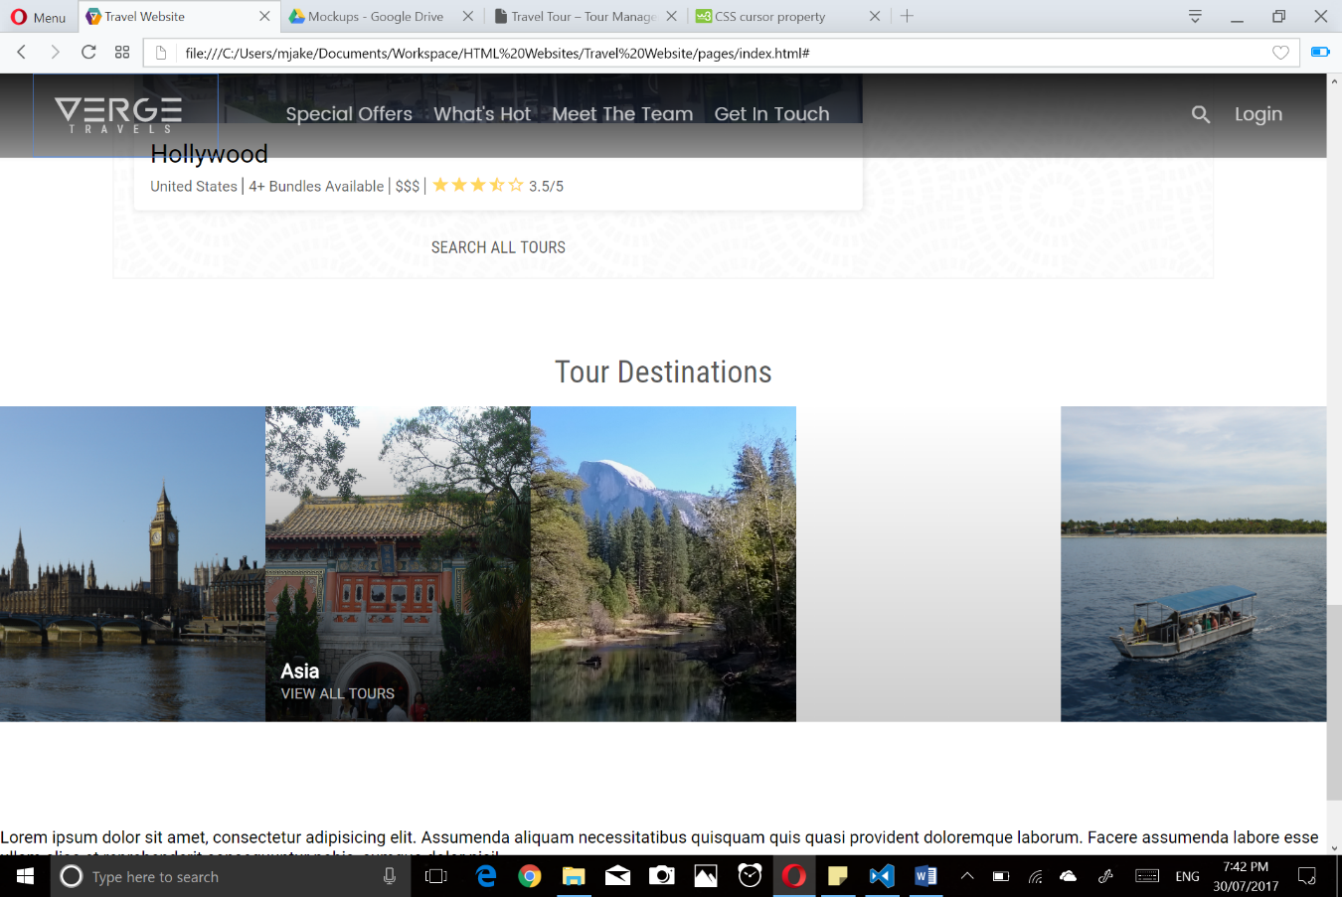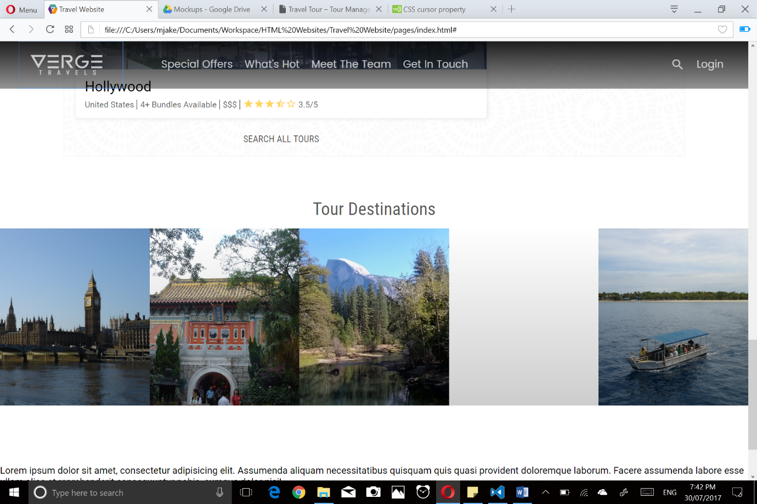

**Figure 19/20:** Hovering shows more information. CSS Transitions interpolate between Inactive and Active states (left and right respectively).

I also worked on the ‘Testimonial’ section of the Landing Page. It consists of a picture with a gradient overlay, acting as the background, with a heading, a circular picture of the person, and that person’s quote overlaid on top. I chose to use the gradient ‘Mello’, from UI Gradients, for its distinctive colour scheme which contrasts with the relatively monochromatic look of the rest of the page (<https://uigradients.com/#Mello>).

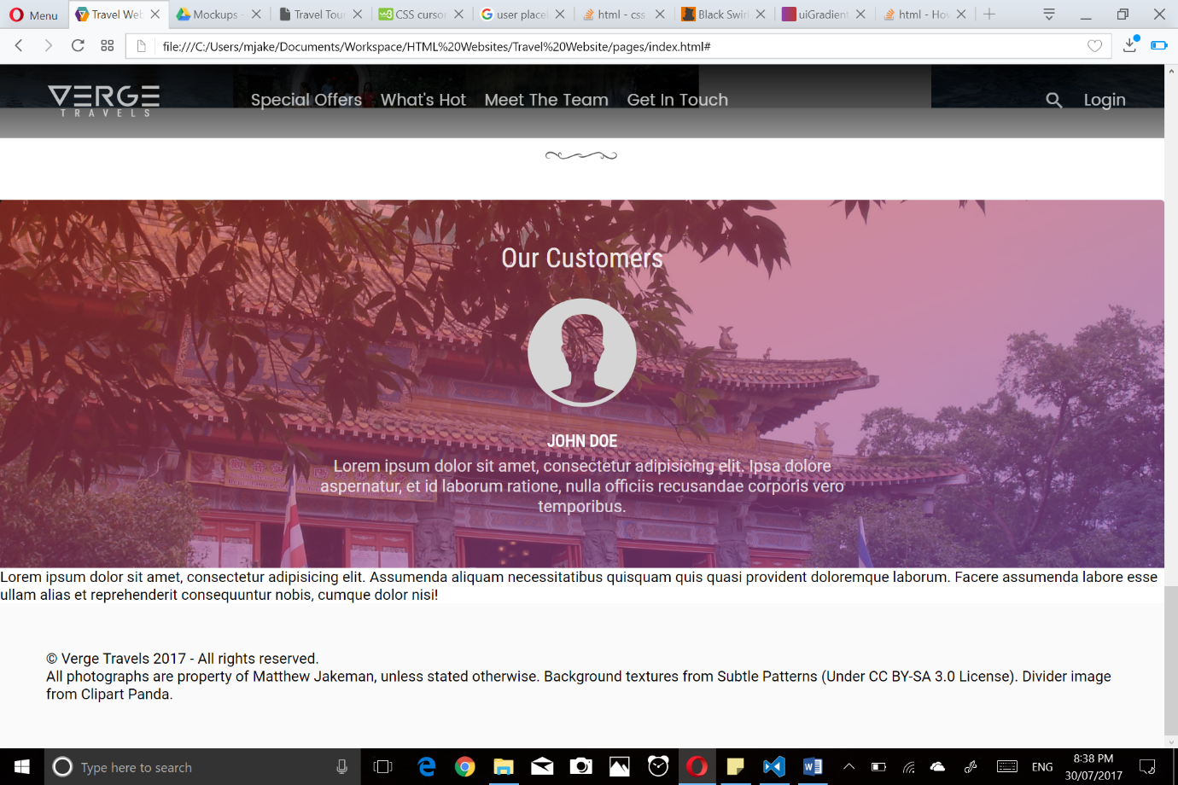

**Figure 21:** The ‘testimonial’ section of the page. The image, name, and text are placeholders, and will be filled in in a later sprint.

Tuesday 1st August 2017

I finished the landing page today, finalising the testimonial section and adding a footer. The footer was inspired by Microsoft’s own footer on their website. I thought it was a clean, functional footer that blended in nicely with the rest of my page. I added copyright text at the very bottom.

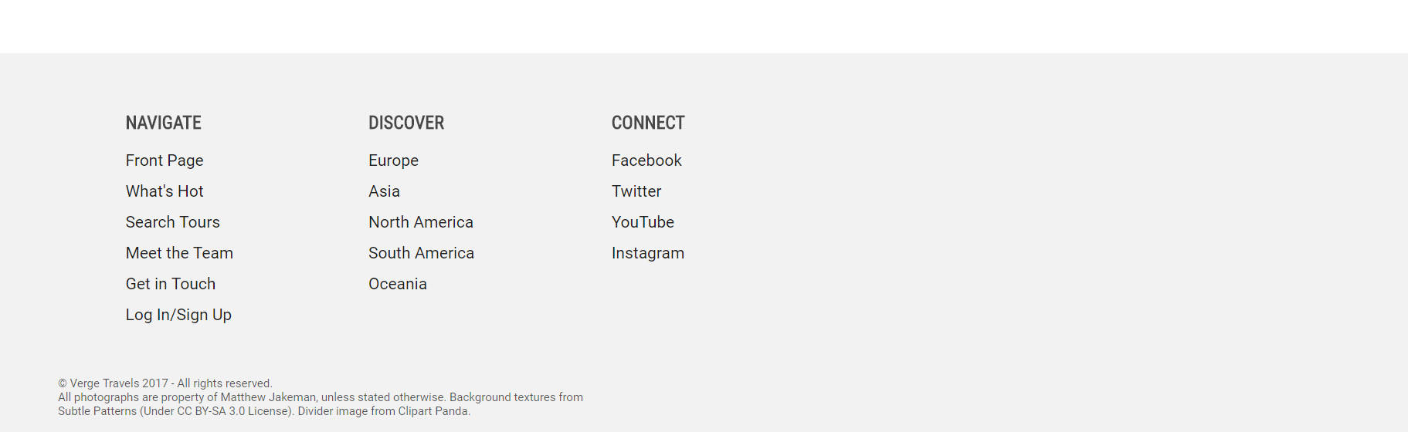

**Figure 22:** The footer. It provides links to all key pages, each of the five destinations this site will offer, and four Social Media channels.

I also made several other minor changes, before finishing up the landing page. I changed the contents of the navigation bar, removing ‘Special Offers’, as I felt it was the same thing as ‘What’s Hot’. The Navigation Bar uses an Inline SVG logo so that the subtitle can be styled using CSS.

**Review**

During the implementation of this section, I found myself faced with various design and structure problems I had not anticipated when I first conceptualised this website (For example, implementing a sticky navigation without JavaScript). Despite this, I was able to stay consistent with the original design, with the final result being much the same.

The only notable deviations from the original design were all design based, with the footer (which contained a logo and various levels of contrast) being streamlined with a cleaner, more spacious design. The Recommended Tours section gained the addition of a horizontal ‘Tour Filters’ header, which I believe greatly improves the flow of the page (and the usability, assuming search functionality was implemented using JavaScript or Python).

The Popular Destinations section was also streamlined, with the contrast being removed, and all five destinations being displayed simultaneously. The ‘label on hover’ concept was modified to include a gradient backdrop.

Finally, the testimonials section was given a background image (and subsequent gradient overlay), which I believe added a much-needed respite from the relatively monotone colour scheme of the rest of the page.

## Sprint 2: Responsive Design

**Pre-Implementation Plan**

Tuesday 1st August 2017

From the very beginning, I planned to make this website fully responsive. During the construction of the Landing Page (which contains nearly all of the components used by other pages), I made heavy use of flexboxes and other modern CSS components and techniques to ensure ‘responsiveness’.

I decided that a Material Design inspired five-breakpoint system would be best for my website. This involves the creation of four additional CSS files (xsmall, small, medium, large, and xlarge), which modify the original CSS Styling (style.css) to adapt to different layouts. This was primarily done as it was the easiest option to maintain (as opposed to multiple media queries inside one document). The system utilises CSS Media Queries to apply one of the five stylesheets to the corresponding screen size where necessary (See Table).

|  |  |
| --- | --- |
| **Breakpoints and Corresponding Screen Width** | |
| Extra Small (‘responsive-xsmall.css’) | 0px – 480px |
| Small (‘responsive-small.css’) | 480px – 840px |
| Medium (‘responsive-medium.css’) | 840px – 1280px |
| Large (‘responsive-large.css’) | 1280px – 1440px |
| Extra Large (‘responsive-xlarge.css’) | 1440px+ |

Decisions about each individual section of the page, while mostly predetermined, will be discussed in the following section for organisation (decisions and how they are implemented are located in the same area). I decided to work on one stylesheet at a time, so that I could reuse code (e.g. Extra Small and Small are similar in many senses).

**Implementation (CSS)**

*Extra Small*

*Navigation –* I changed the navigation bar to use absolute positioning instead of being fixed at the top of the screen. This is because fixed navigation bars are uncommon on small screens and would only hinder the user experience on a phone. Everything, with the exception of the logo, is hidden from the user. Proper navigation will be provided at the bottom of the page through the footer. The logo is horizontally centred, and uses full opacity. The backdrop is hidden.

*Hero Image –* The hero image remains unchanged. The hero image text and button is centred, and reduced in size to provide an uncluttered landing page for mobile users. The ‘&’ symbol in the hero text has also been hidden, through the use of a span element.

*Features –* The features section (which uses a flexbox for layout), changes radically, with each feature now taking up the full-page width, and being stacked vertically.

*Recommended Tours –* The Recommended Tours section was modified significantly. The width was set to 100%, as opposed to 90% + 50px padding. The input widths of the Tour Filters were set to 80%, and stacked vertically (through the use of a flexbox). Extra labels were added to the HTML and hidden by default, only shown on small screens like this. These were placed directly above the field the correspond to. Multiple other minor changes were made.

The height of the background was set to 500px to account for the extra space used by the inputs. For the recommended tours section itself, the sidebar is hidden (it is not essential to the flow of the page), and the ‘cards’ are expanded to take up the full-page width. The ‘subtitle’ which provides information about the tour is hidden, and the design is streamlined.

*Destinations –* The destinations section, like the features section, uses a flexbox to present its contents vertically stacked. The gradient overlay also changes from top to bottom to right to left.

*Testimonials –* The original styling was already sufficiently responsive. I adjusted to height of the background to fully encompass the quote.

*Footer –* I hid the ‘sitemap’ parts of the footer as they were not essential for mobile navigation (destinations can be accessed by the destinations section). The ‘Navigate’ section was expanded to take the full-page width, and padding and font size were increased. The footer now acts as the primary navigation for the page. The copyright text and logo were ‘unfloated’ and centred.

Small

I copied and pasted the Extra Small CSS file, making adjustments that would better suit the website for a portrait tablet orientation.

*Navigation –* The navigation remains unchanged from the Extra Small stylesheet.

*Hero Image –* Hero Image is not modified, like in the Extra Small stylesheet. The heading in the hero text was made slightly larger to make better use of screen real estate.

*Features –* The features section closely resembles the original stylesheet (style.css), with the descriptive text being hidden.

*Recommended Tours –* The width of each input in the Tour Filters segment is reduced to 70%, resulting in ‘breathing room’ on each side of the textboxes. For the recommended tours segment, the extra information for each ‘card’ was unhidden.

*Destinations –* The destinations section remains unchanged from the Extra Small stylesheet.

*Testimonials –* The height of the testimonials section was reduced to better accommodate the larger screen space (400px).

*Footer –* The footer remains unchanged from the Extra Small stylesheet.

Medium

Unlike ‘Small’, ‘Medium’ is based off the original stylesheet (style.css), and is targeted at small screen desktop users as opposed to mobile.

*Navigation –* The unordered list inside the navbar was changed to use 95% width as opposed to 80%. The search icon and Verge Travels logo were adjusted slightly to fit.

*Hero Image –* I changed the position of the hero text vertically on the screen, and modified the size of the heading and subtitle to fit the target screen size. The ‘&’ symbol hidden in ‘Extra Small’ and ‘Small’ was made visible.

*Features* – Features is unchanged from the original stylesheet (style.css).

*Recommended Tours –* The Tour Filters were modified slightly, with the input widths being reduced to 160px. The section itself now uses 100% of the page width (with 50px padding).

*Destinations –* The destinations section remains unchanged from the original stylesheet.

*Testimonials –* The testimonials section remains unchanged from the original stylesheet.

*Footer –* The footer section remains unchanged from the original stylesheet.

Large

The large stylesheet, like the medium size, is almost identical to the original stylesheet with a few subtle changes.

*Navigation –* The font size has been set to 110%. The search icon has been adjusted to fit.

*Hero Image –* The hero text has been vertically positioned in the middle of the page. The font size has been increased for larger displays. The subtitle and button have been shifted upwards.

*Features –* The features section has been set to use only 60% of the page width, horizontally centred. This allows the user to focus on all four features at once instead of being required to move their head. This aids usability and helps increase user immersion.

*Recommended Tours –* The Recommended Tours section remains unchanged from the original stylesheet. Certain lines of code are repeated to ensure that the correct layout is applied (browser issue with Chrome and Opera).

*Destinations –* The destinations section remains unchanged from the original stylesheet.

*Testimonials –* The testimonials section remains unchanged from the original stylesheet.

*Footer –* The footer section remains unchanged from the original stylesheet.

Extra Large

The Extra Large stylesheet is almost identical to the large stylesheet, except it uses fixed widths (in pixels) for typically wide elements. This is to accommodate large monitors and widescreen (21:9) screens.

*Navigation –* The navigation bar remains unchanged from the ‘Large’ stylesheet.

*Hero Image –* The hero image remains unchanged from the ‘Large’ stylesheet.

*Features* – The features section was set to use 1000px instead of the 60% used by the ‘Large’ stylesheet.

*Recommended Tours –* The recommended tours section uses a fixed width of 1280px instead of the 90% used by the ‘Large’ Stylesheet.

*Destinations –* The destinations section remains unchanged from the original stylesheet.

*Testimonials* – The testimonials section is identical to the original stylesheet, except that the ‘p’ element uses a width of 500px.

*Footer –* The footer is unchanged from the original stylesheet.

**Review**

I encountered virtually no issues when implementing this Sprint. The decisions I made at the beginning of this Sprint, and during the construction of the Landing Page helped significantly.

The only case of me having to modify the HTML Code was during the ‘Extra Small’ and ‘Small’ versions of the Tour Filters section. I had to add a second set of labels which were hidden by default for mobile use, so that they could be arranged without extensive use of absolute or relative positioning.

Overall, this Sprint was completed with very little issues in a very short amount of time. I plan to add to these responsive stylesheets in the coming sections for additional components that were not covered by the landing page, although it should be infrequent. The multiple breakpoint system used by my website should make maintenance like this significantly easier.

## Sprint 3: Destinations & Categories

**Pre-Implementation Plan**

Wednesday 2nd August 2017

Now that I have created the Landing Page and made it fully responsive, I plan on adding subpages for each ‘Destination’ and ‘Tour’. A Destination will represent one of the five regions I have chosen to include in my project – Europe, Asia, North America, South America, and Oceania, as I have pictures from each of these continents readily available.

A ‘Tour’ will represent an important City or Attraction inside these regions. For example, ‘Europe’ would be the Destination, and ‘London’ would be the Tour. This Sprint will involve the creation of a tree-like structure, which contains a HTML file for each tour, and an ‘index’ file representing each of the five destinations. The folder structure looks as follows:

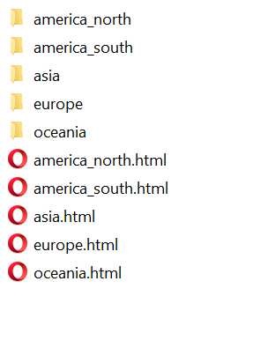

**Figure 23:** Sample folder structure for the subpages. There are five ‘index’ pages, which hold links to each and every ‘tour page’ inside their corresponding folder.

I decided the best way to go about creating these subpages would be to create a template. Inside the ‘pages/templates’ folder, I created two HTML documents titled ‘destination.html’ and ‘tour.html’. I placed the ‘tour.html’ inside a folder named ‘tour’ to preserve relative paths when copying.

**Implementation**

I started by copying the Landing Page into ‘destination.html’ and fixing the relative paths. I changed the page title and removed everything except for the Recommended Tours section and the Hero Image.

I decided to create two additional classes of ‘Hero Image’ for the destination and tour pages respectively – a medium and small size. The medium hero image uses 60% of the page height, as opposed to 100%. I made slight adjustments to the font sizes, and came up with the following:

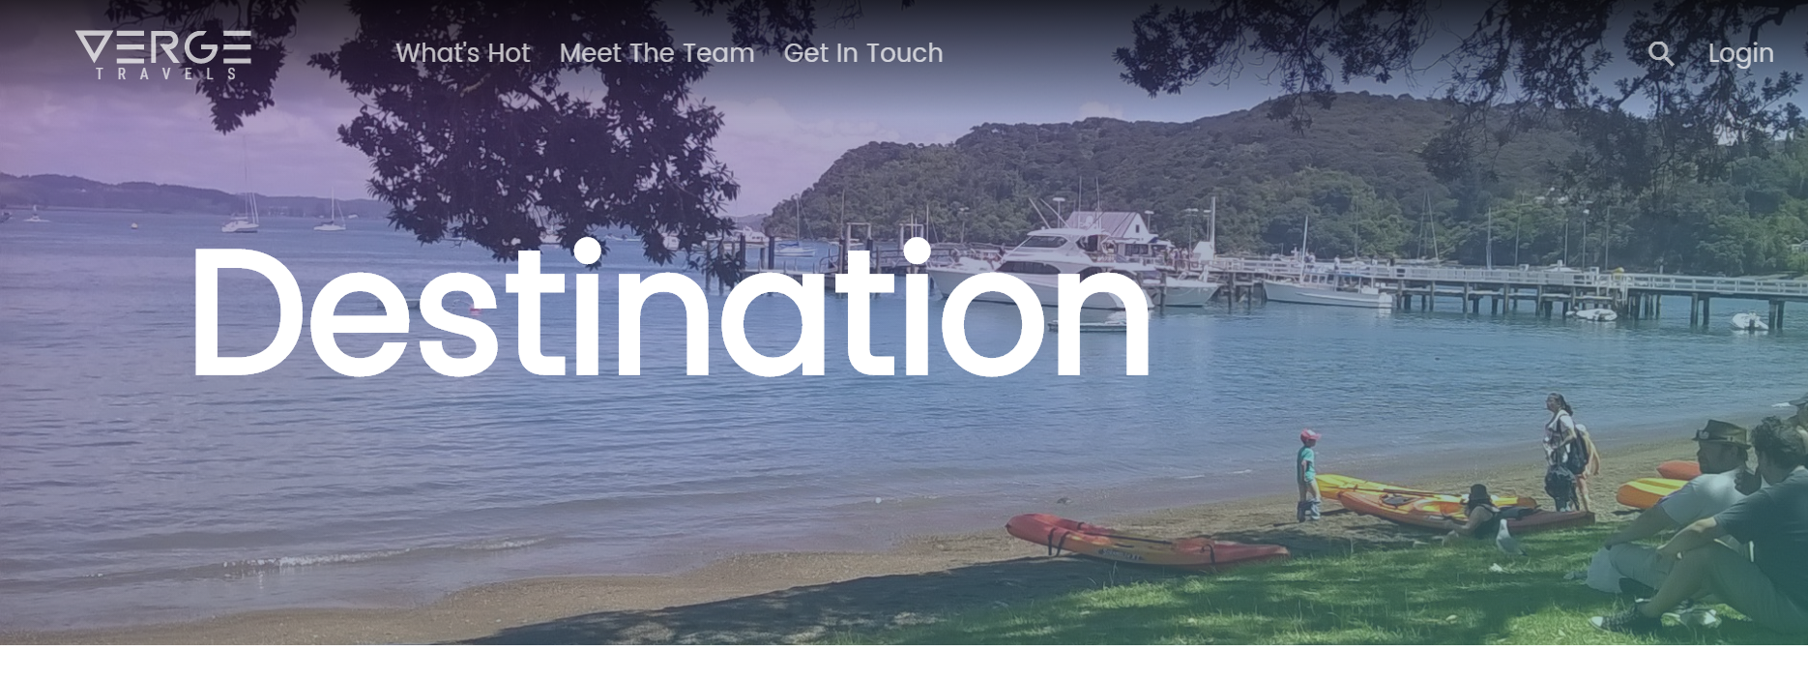

**Figure 24:** Medium size hero image and ‘Destination’ placeholder text.

The next part of the Destination Template I created was the ‘Tree Widget’, which shows the current page ‘location’. For example, if you were on the London tour page, the Tree Widget would read: ‘Destinations / Europe / London’ and provide links to each of the three pages/sections. I plan to include this on both Destination and Tour pages.

I experimented with possible designs, deciding to highlight the final entry in a blue-green colour and underline all the links for accessibility. The final design is as follows:



**Figure 25:** Finalised Tree Widget design.

For the actual tour list, I made use of the ‘reusable component system’ I had created earlier. I took the recommended tours section from the Landing Page, removed the Tour Filters, and replaced the ‘recommended tours’ with the tours for that particular region (placeholders for the template). The original footer from the page was used.

I moved on to creating the first actual page, deciding to create Europe first. I came across many problems with the template, namely how to apply the tour gradient and background image to the ‘tour card’. I decided on a system where each tour gets a custom image plus gradient assigned through the use of CSS classes. This would also allow me to create custom hero images for each tour, using the same system.

I chose background images for each of the tours. The following table lists the name of each Destination, Tour, and their corresponding Gradient, taken from the website UI Gradients.

|  |  |
| --- | --- |
| **Tours and Corresponding Gradient Overlays** | |
| **Tour/Destination** | **Gradient Name** |
| **Europe** | **Summer** |
| London | Summer |
| Letterkenny | Cinnamint |
| Paris | Celestial |
| Haifa* | Dania |
| **Asia** | **King Yna** |
| Singapore | Ibiza Sunset |
| Hong Kong | King Yna |
| Kualar Lumpur | Orange Fun |
| **North America** | **Dawn** |
| Toronto | Sunset |
| Niagara | Sherbert |
| Hollywood | Venice |
| San Francisco | The Blue Lagoon |
| **South America** | **Meridian** |
| Rio de Janeiro | Meridian |
| **Oceania** | **Dirty Fog** |
| Russell | Calm Darya |
| Fiji | Visions of Grandeur |

*\*While Israel is geographically in Asia, it is considered by many to be part of Europe, and I felt that for usability purposes, it would better fit under the ‘Europe’ region.*

I proceeded to copy and paste the Destination template several times, modifying each copy for its respective Destination. The Hero Image’s gradient overlay was changed to the Destination’s respective gradient described above.

I began work on the Tour template. It uses a modified Destination template, but with a smaller hero image (40% of the page height), and no tour list. The Tree Widget was expanded to contain the name of the Destination *and* the name of the Tour.

I began creating a ‘Tour Description’ section. This section will consist of two parts – the main section and the sidebar. The main section will have a description of the tour (placeholder text), the information bar (with the extra information from the card), and a gallery. The sidebar will have purchase information, including tour name, options, start and end dates, and more.

I created the two empty sections first. They both have a 1-pixel light grey border. The sidebar has three inputs for ‘Options’, ‘Start Date’, and ‘End Date’. The styling is a variation of the Tour Filter form, but using light colours instead of dark greys. I set the background image to use the Subtle Pattern ‘Swirl’, which is also used on the Recommended Tours section.

The ‘GET QUOTE’ button is a modified version of the ‘Learn More’ button from the Landing Page Hero Image. I coloured it light blue-green to match the Tree Widget.

Next, I filled out the actual Tour Description panel, using Lorem Ipsum as placeholder text. The ‘info bar’ will use the extra information from the tour card. For the gallery, I used a flexbox, which holds container articles and HTML ‘img’ elements for the actual images. The container article has a black background, and is completely obscured by the image. Upon hover, the image loses opacity, darkening it.

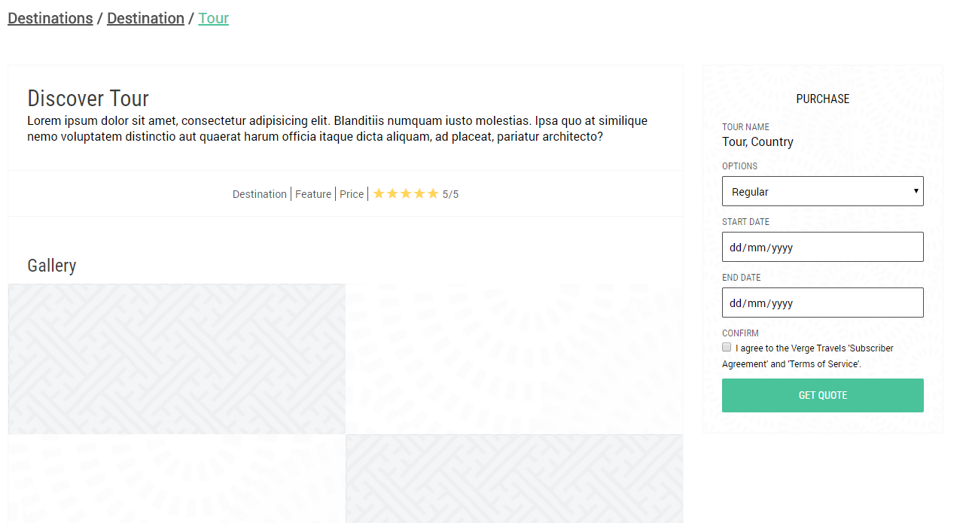

**Figure 26:** The Tree and Tour Description Widgets that make up the Tour Template.

I proceeded to copy and paste this Tour template multiple times, filling it out for each tour. The small hero image used by the template was set to each tour’s corresponding background image and gradient overlay. The same overlay is used across hero image and tour card for consistency. I added the appropriate images for each tour into the gallery section – approximately four per tour.

I tested the website for responsiveness, and found that the ‘Tour’ section did not scale well. I added CSS to the responsive stylesheets as follows:

Extra Small – I adjusted the small hero image text size and centred the tree widget. For the tour description section, I made both components take up the full width, with the description above the sidebar. I made slight adjustments to font size. I also filled in the information bar’s background with a light grey and increased the padding. I stacked the gallery vertically, with each image taking up the full-page width.

Small – The same as Extra Small, except the gallery shows two images side by side. Sidebar takes up 70% width instead of 100%, margins increased.

Medium & Large – No change from original stylesheet.

Extra Large – Section uses fixed width of 1280px. Same with tree view.

**Review**

This section went completely according to plan without a hitch. I was able to reuse many components from the landing page, and the use of templates made this far easier and faster than it would have been, had I done everything manually. The folder structure also makes this project very easy to maintain and update with new tours. I plan to use the responsive components of this Sprint in the next stage of the project for additional pages.

## Sprint 4: More Pages

**Pre-Implementation Plan**

Thursday 3rd August 2017

The Second to Last Sprint is concerned with the creation of additional ‘utility’ and ‘educational’ pages. These include Login Prompts (Note: this prompt does not function, as such capability would require JavaScript, which is outside the scope of this project), About pages, Contact forms, and more.

I plan to use slightly modified versions of existing components to create a ‘content’ section, which will contain plain text. The Login page is an exception, as it will use a ‘Login’ div element positioned absolutely on top of a full-size Hero Image. I will create this later in this Sprint.

I had previously planned to add trending and destinations pages, however decided that they would be redundant and counterproductive to implement, as they already exist on the Landing Page. I decided to instead update the navigation bar and footer to include a ‘Destination’ button, and linked it and the already existing ‘What’s Hot’ button to their respective counterpart sections on the Landing page.

**Structure & Styling**

I started with the ‘Meet the Team’ page first. This is an about page that contains a brief history of the company (placeholder text) and an overview of the ‘Verge Travels Team’.

I started with a ‘Small Hero Image’, using a picture of Haifa, Israel, and a Purple/Pink coloured gradient overlay. I created a ‘content’ section using a section and a div element. It is virtually the Recommended Tours section, minus the sidebar and header. It contains sample text, a label designating me as the ‘CEO, Developer, & Designer’ of Verge Travels, and a few (humorous) acknowledgements to fellow students who helped with sounding out ideas and giving me feedback about the usability of the website.

I then worked on the ‘Meet the Team’ page, which contains the physical address and contact information for Verge Travels. The phone and email are fictitious, while the address is the physical location of St Patrick’s College Silverstream. I used a picture of Niagara Falls for the small hero image, and set the gradient overlay to a Blue/Green combination.

I started on the Login page next. I used a transparent black overlay, with a modified version of the form from the Tour Description section. I absolutely positioned it over the hero image (Same as Hong Kong), right in the centre of the page. I made the heading darker and increased the font size. I also changed the text boxes to use dark colours instead of light, and modified the labels for contrast reasons. Finally, I applied drop shadows to some of the elements, notably the ‘Log In’ button. The Login page looks as follows:

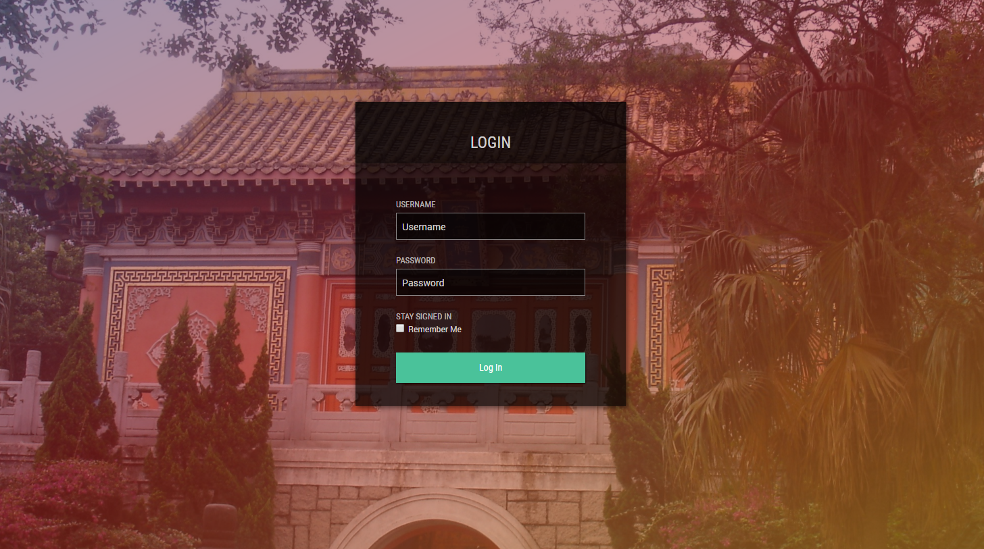

**Figure 26:** The login prompt is essentially an inverted version of the Tour Purchase form.

I started on the final utility page – the Search page. I copied and pasted the Contact page, changing the necessary titles, and setting the hero image to use the London image and gradient. I added the Tour Filters component of the Recommended Tours section from the Landing page. As implementing actual search functionality is outside the scope of this project, I left an indicator of where search results would appear.

Finally, I tested all pages for responsiveness. Although the search page worked without modification, I decided that something was missing between the hero image and the Tour Filters, so I added a Tree Widget for all utility pages (with the exception of the login page). The other pages also scaled correctly, and did not need to be modified.

**Review**

Thanks to the Responsive Components added throughout previous Sprints, this Sprint was immensely quick to complete, requiring little to no maintenance for the responsive stylesheets. As of this Sprint, the entire project is structurally complete. All that remains is to validate and bug test the site, which will be performed in the fifth and final Sprint.

## Sprint 5: Polishing & Finalisation

After four Sprints of structure and styling implementation, the project is now complete. This Sprint will concern itself with ensure that all code is valid, and that the site works consistently across major browsers. The browsers that are used to test the website are: Google Chrome, Opera, Microsoft Edge, and Firefox.

**HTML Validating**

<https://validator.w3.org/nu/#file>

*I have chosen to only troubleshoot errors, as fixing warnings may cause the project to be overdue, and could interfere with the basic structure of the page(s).*

*index.html –* Slight modifications were made tothe Landing Page to pass verification. This included the adding of alt tags to images, and the enclosing of h2 elements in the footer in list items.

*about.html* – Passed with no errors.

*contact.html* – Passed with no errors.

*login.html* – Passed with no errors.

*search.html* – Passed with no errors.

*destination.html* – Passed with no errors.

*america_north.html* – Passed with no errors.

*america_south.html – Passed with no errors.*

*oceania.html* – Passed with no errors.

*europe.html* – Passed with no errors.

*asia.html* – Passed with no errors.

*tour.html* – Slight modifications made to codebase. Stray img end tags were removed, alt tags were added. All tour pages were updated to match, and were validated individually.

All pages passed the HTML Validation Test.

**CSS Validation**

<https://jigsaw.w3.org/css-validator/#validate_by_upload>

*Again, warnings were ignored in favour of errors. This is because the warnings did not affect usability, and could have impacted design.*

*style.css* – Passed with no errors.

*responsive-xsmall.css* – Passed with no errors.

*responsive-small.css* – Passed with no errors.

*responsive-medium.css* – Passed with no errors.

*responsive-large.css* – Passed with no errors.

*responsive-xlarge.css* – Passed with no errors.

All stylesheets passed the CSS Validation Test.

**Browser Compatibility**

Google Chrome – No visible issues or problems.

Opera – No visible issues or problems.

Microsoft Edge – Letter ‘G’ in Verge Travels logo does not display properly in most recent public version. SVG rendering fixed in newer insider versions, which were used to test the site – No visible issues or problems.

Mozilla Firefox – Minor visible issues or problems. The logo subtitle is more condensed that other browsers, does not impact design. Fonts are rendered slightly differently than other browsers. The visual changes do not impact usability and functionality, only appear slightly different from other mainstream browsers. There is reportedly an issue where icon fonts do not display correctly, however I have not experienced this during my testing.

**Compliance**

The specifications for this website, created at the beginning of this task, and an explanation of how they are implemented into this website:

Create a multi-page website

This website contains a Landing Page, several Utility pages, Index Pages for each destination, and a page for every Tour. There is a total of **25 pages** in this project, excluding the two template pages.

Create navigation to efficiently travel between pages

There is navigation provided through both the navigation bar and footer, and almost any page can be reached within three clicks.

Create a user-friendly design that is accessible and visually pleasing

Bright, but not overwhelming, colours are used. Large background images take centre stage, and are the main focus for the user. This gives the website a friendly and inviting feel to prospective new users.

Create a UI scheme that is consistent throughout the website

The exact same navigation bar and footer is used through the entire website. Users will have the same method of navigating available to them, no matter what page they are on.

Create a fully responsive website that can adapt to screens of any shape and size across a range of device types

The website is fully responsive, utilising a five-breakpoint system to scale between tiny mobile screens, and large widescreen monitors. Every page is accessible to the user, no matter what form factor the site is accessed from.

Use a range of different images (Vector Graphics, PNGs, JPGs, etc).

A mix of JPG, PNG, and SVG files are used. The logo in the navigation bar is implemented using Inline SVG, while the divider, hero images, and tour card previews are all images linked through HTML and CSS methods.

Enhance and integrate images into the website through advanced CSS techniques

Images are integrated into the page itself through the use of CSS gradient overlays. Instead of being merely added to the page, they become part of the User Experience, and are layered beneath and above objects, making the experience more immersive. Furthermore, the logo is implemented using Inline SVG, allowing it to be styled through CSS.

Add visual flair through use of CSS Transitions on interactable elements

Most buttons are styled using CSS Transitions to show interactivity and provide the user with hover feedback. They also serve to make the website more aesthetically pleasing.

Have the ability to be displayed in three or more different browsers.

The Verge Travels website is fully functional in Google Chrome, Opera, Mozilla Firefox and Microsoft Edge, and appears with only minor visual inconsistencies. Google Chrome and Opera are identical.

**Statement of Authenticity**

*I, Matthew Jakeman, hereby certify that all work in this project, unless explicitly stated otherwise, and used under appropriate license, is of my own creation, and in accordance with the regulations set forth by the Achievement Standard.*

***“Verge Travels” – NCEA Level 1 Digital Technologies (AS91073)***

*By Matthew Jakeman*